* Hysteresis hɪstə'risɪs 滞后性

1. Intrinsically Stretchable OLEDs with Exciplex

Bis(3-aminopropyl) terminated poly(dimethylsiloxane) (H2N-PDMS-NH2, Mn = 5000-7000) were purchased from Gelest.

polydimethylsiloxane (PDMS)

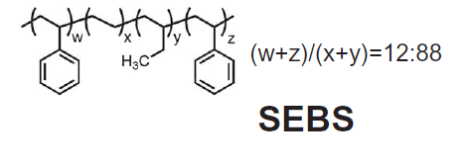

Styrene-ethylene-butadiene-styrene (SEBS)

Isopropanol 异丙醇

solution of AgNWs dispersed in isopropanol (Nanopyxis Ltd., Korea) was spin-coated onto the **PDMS** film and heated on a hot plate at 60°C for 10 min to remove any remaining organic solvent from the coated layer

A thin layer of **PDMS** (Sylgard 184 Silicone Elastomer, Dow Corning) was applied to the glass.

**polyurethane urea (PUU)**, Carboxylic acid groups of PUU was designed to form

hydrogen bonds with the carbonyl groups of poly(vinylpyrrolidone) on the AgNW surface, resulting in an enhanced affinity of AgNWs for PUU

**bottom gate - bottom contact** (in which the drain and source electrodes are positioned directly on the dielectric film),

**bottom gate - top contact** (in which the source and drain electrodes are grown on the organic semiconductor)

**top gate - bottom contact** (in which the dielectric film is deposited on the organic semiconductor and the gate contact is placed on top of it).

silver nanowires (AgNWs) embedded in a rubbery **poly(urethane acrylate) (PUA)** matrix

**PEI** in methoxyethanol (diluted by adding 2-methoxyethanol to 0.4 wt %)

**polyethylenimine (PEI),** 80% ethoxylated solution (3540 wt % in H2O, average Mw ∼70 000), 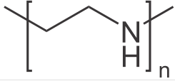

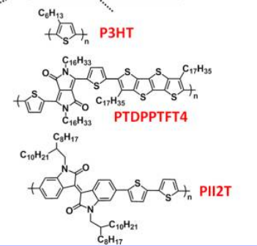

脲urea (NH2)2CO

**PBD**: Polybutadiene

**PE-P3HT** diblock copolymer (with stretch ability of 600%, mobility of 2*10-2), **PTDPPTFT4** (with stretch ability of 100%, mobility of 1.49*10-1), PII2T (with stretch ability of 100%, mobility of 5.07*10-1), **P3HT fiber** (with stretch ability of 70%, mobility of 18), **Semiconducting CNT** (with stretch ability of 100%, mobility of 0.18)

PBD:

Yu and coworkers from the Pei group developed shape-memory stretchable light-

LEDs using transparent SWCNT/poly( *tert* -butylacrylate) (P*t*BA) composite electrodes.

**Super Yellow** 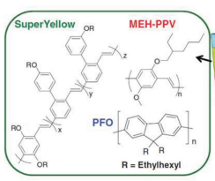

Compared to the wide exploration of biodegradable insulators, research efforts in biodegradable semiconductors, especially polymer-based, remain sparse.

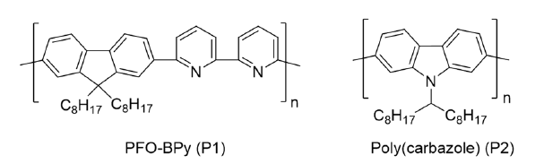

**PFO-BPy, Poly(carbazole)[****1****]**

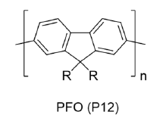**PFO**: poly(9,9-dioctylfluorenyl2,7-diyl)

Although branched alkyl chains provide polymers with better solubility, they are also observed to invariably hinder close intermolecular **π−π stacking** in polymer transistors.

聚乙烯亚胺PEI polyethylenimine

ethoxylated polyethylenimine (PEIE, Mw=75,000 g/mol, Sigma-Aldrich) dissolved in 2-methoxyethanol to 0.4 wt% concentration was spin-coated at 5000 rpm for 60 s. [2]

Stretchable Au/PDMS anodes were prepared by depositing a 15 Å **titanium adhesion layer** followed by 200 Å of gold onto a PDMS substrate in an e-beam evaporator at 10 − 6 mbar at a rate of 1 Å/s.[3]

AuNP coating on the exposed AgNWs involved immersing AgNWs/PDMS composite electrode in 0.5 mM HAuCl4·3H2O aqueous solution for 2 min to allow for the Ag-Au galvanic replacement process to take place. The coated electrodes were rinsed with deionized (DI) water and dipped in NH4OH solution (28%) for 1 min to dissolve the by-products of AgCl layer that were formed on the NWs**.[****4****]**

poly[9,9-dioctylfluorene-co-N-(4-butylphenyl) diphenylamine] (TFB)[5]

[聚(9,9-二辛基芴-CO-N-(4-丁基苯基)二苯胺)](javascript:showMsgDetail('ProductSynonyms.aspx?CBNumber=CB82717238&postData3=CN&SYMBOL_Type=D');)

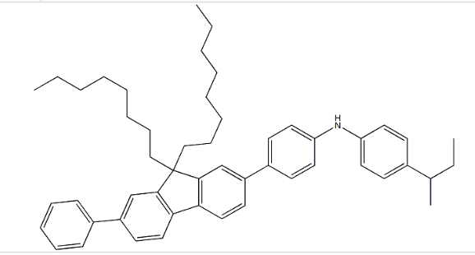

[1] T. Lei; I. Pochorovski; Z. Bao, *Acc. Chem. Res.* **2017**, *50,* 1096.

[2] L. Li; J. Liang; H. Gao; Y. Li; X. Niu; X. Zhu; Y. Xiong; Q. Pei, *ACS applied materials & interfaces.* **2017**, *9,* 40523.

[3] H. L. Filiatrault; G. C. Porteous; R. S. Carmichael; G. J. Davidson; T. B. Carmichael, *Adv. Mater.* **2012**, *24,* 2673.

[4] K. Sim; Z. Rao; H.-J. Kim; A. Thukral; H. Shim; C. Yu, *Science Advances.* **2019**, *5,* eaav5749.

[5] D. Di; A. S. Romanov; L. Yang; J. M. Richter; J. P. H. Rivett; S. Jones; T. H. Thomas; M. Abdi Jalebi; R. H. Friend; M. Linnolahti; M. Bochmann; D. Credgington, *Science.* **2017**, *356,* 159.